**EXPERIMENT NO. 2**

**TITLE :**

To create mark-sheet using Spreadsheets like MS Excel.

**OBJECTIVE :**

* To learn how to create Mark sheet.
* To learn how to use MS Excel.

**THEORY :**

Microsoft Excel is a spreadsheet program that allows users to organize, format, and calculate data. It is a powerful tool for data visualization and analysis.

Excel allows the users to create, edit, and format spreadsheets, containing numerical data, formulae, and chart. It is commonly used for the financial calculations, budgeting, data analysis, and various business and academic purposes

**DEMONSTRATION :**

Key word for formulae:

* + - For Sum:

=SUM(C3:G3)

* + - For Pass/Fail

=IF(AND(C3>=35,D3>=35,E3>=35,F3>=35,G3>=35),"pass","fail")

* + - For Percentage

=IF(J3="pass",IF(H3>=80,"DIST",IF(H3>=60,"FIRST",IF(H3>=50,"SECOND",IF(H3>=40,"THIRD")))),"FAILED")

* + - For Division

=IF(J3="pass",IF(H3>=80,"DIST",IF(H3>=60,"FIRST",IF(H3>=50,"SECOND",IF(H3>=40,"THIRD")))),"FAILED")

**SCREENSHOT :**

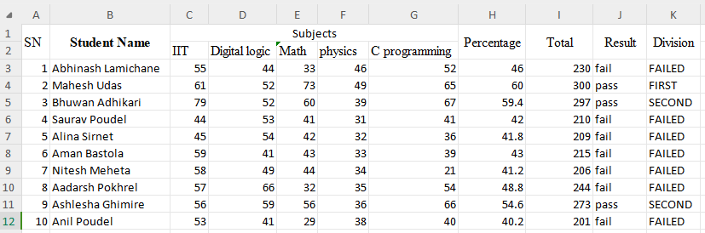

**RESULTS AND DISCUSSION :**

The experiment was successful to creating a mark sheet using MS Excel. The mark sheet contains student name, their obtained marks, total mark, percentage, division and result and remark.

**CONCLUSION :**

This laboratory exercise provided a hands-on experience in creating mark sheet using MS Excel. Students gained practical knowledge of the basic in MS Excel.